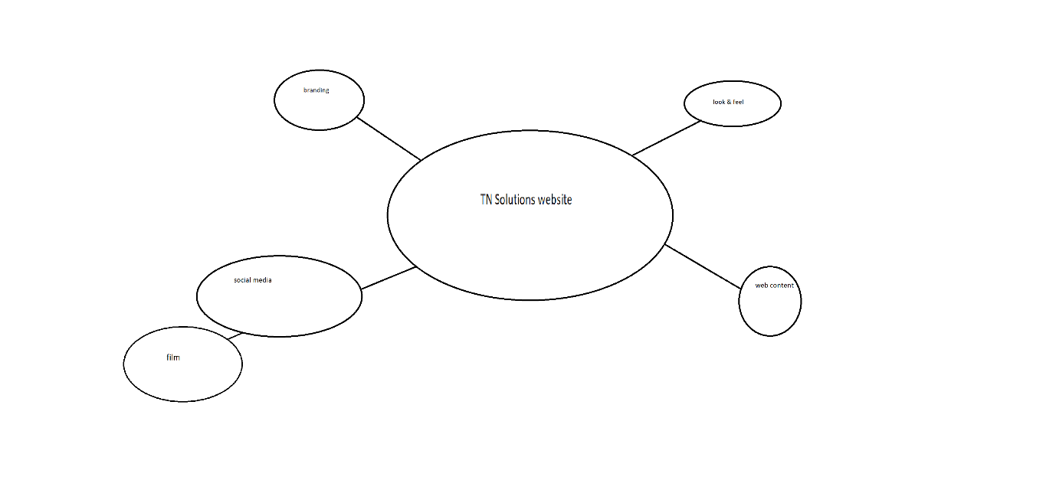Branding:

Logo-

Creation began during project 5 when we were designing business cards for fictitious companies we designed. The logo consists of a monitor displaying my initials merged into one character with bright colouring to draw focus to it.

Business card-

The business card was designed during project 5 and show the earliest concept of the logo. This card features all of the things a business card has, such as contact info, a strapline, and info about the company.

Look & feel:

Colour scheme-

The colour scheme was chosen because the colours are bright and they blend well together. This was done to give an upbeat and fun vibe to the company and the brand as a whole.

Comparison-

The website is unique as, unlike other sites of its kind, it has a more casual look to it rather than a professional look which would attract more people as they are drawn to brightly coloured places.

Visuals-

The websites visuals were chosen to attract web users of all backgrounds into a safe space with a soft atmosphere.

Web content:

-displays pricing and services

-values/contact info

-branding with strapline

Social media:

Film-

The short film attached to the website acts as promotion for the business and the website. This in turn would increase traffic to the site, which would attract more people and potential clients to the site.